

Foundations of Programming
Assignment No. : 11

PROBLEM STATEMENT:
Write a program in C to accept a number from the user and compute the following:
- Square root of the number
- Square of the number
- Cube of the number
- Check whether the number is prime
- Factorial of the number
- Prime factors of the number

OBJECTIVE:
• To understand the use of mathematical operations in C.
• To implement loops and conditional statements
. • To perform number-based computations.
• To enhance logical thinking using menu-driven programs.

THEORY:
Numbers and their mathematical properties play a vital role in programming. Operations such as square, cube, and square root are basic mathematical computations. Prime number checking involves verifying whether a number has exactly two divisors. Factorial is calculated by multiplying a sequence of integers. Prime factorization breaks a number into its prime components. In C programming, these operations can be efficiently implemented using loops, conditional statements, and mathematical functions.

PLATFORM:
Linux

ALGORITHM:
Step 1: Start
Step 2: Declare variables n,i, fact, result as integers and squrt, square, cube as float
Step 3: Accept the value of n from user
Step 4: Calculate square root by raising n to the power 0.5 and store the result in squrt, after checking n>=0.
Step 5: Calculate square by multiplying the number with itself and store the result in square.
Step 6: Calculate cube by multiplying the number with itself 3 for times & store the result in cube.
Step 7: Check the number is prime or not using loop and if-else statement
if n<0
display "not a prime number" and go to step 11.
else
set i=2
while i≤(n^½)
if n%i = =0
Display "Prime No"
else
i++ and Display "Prime No"
Step 8: Calculate factorial using loop
Set fact=1
Repeat from i to n
fact = fact * i
Step 9: Find prime factors vaing while loop
Set i=2
While (n>1)
if (n%i==0)
Display i
n=n/i
else
i++
Step 10: Display square root, square, cube, factorial
Step 11: Stop

FLOWCHART:
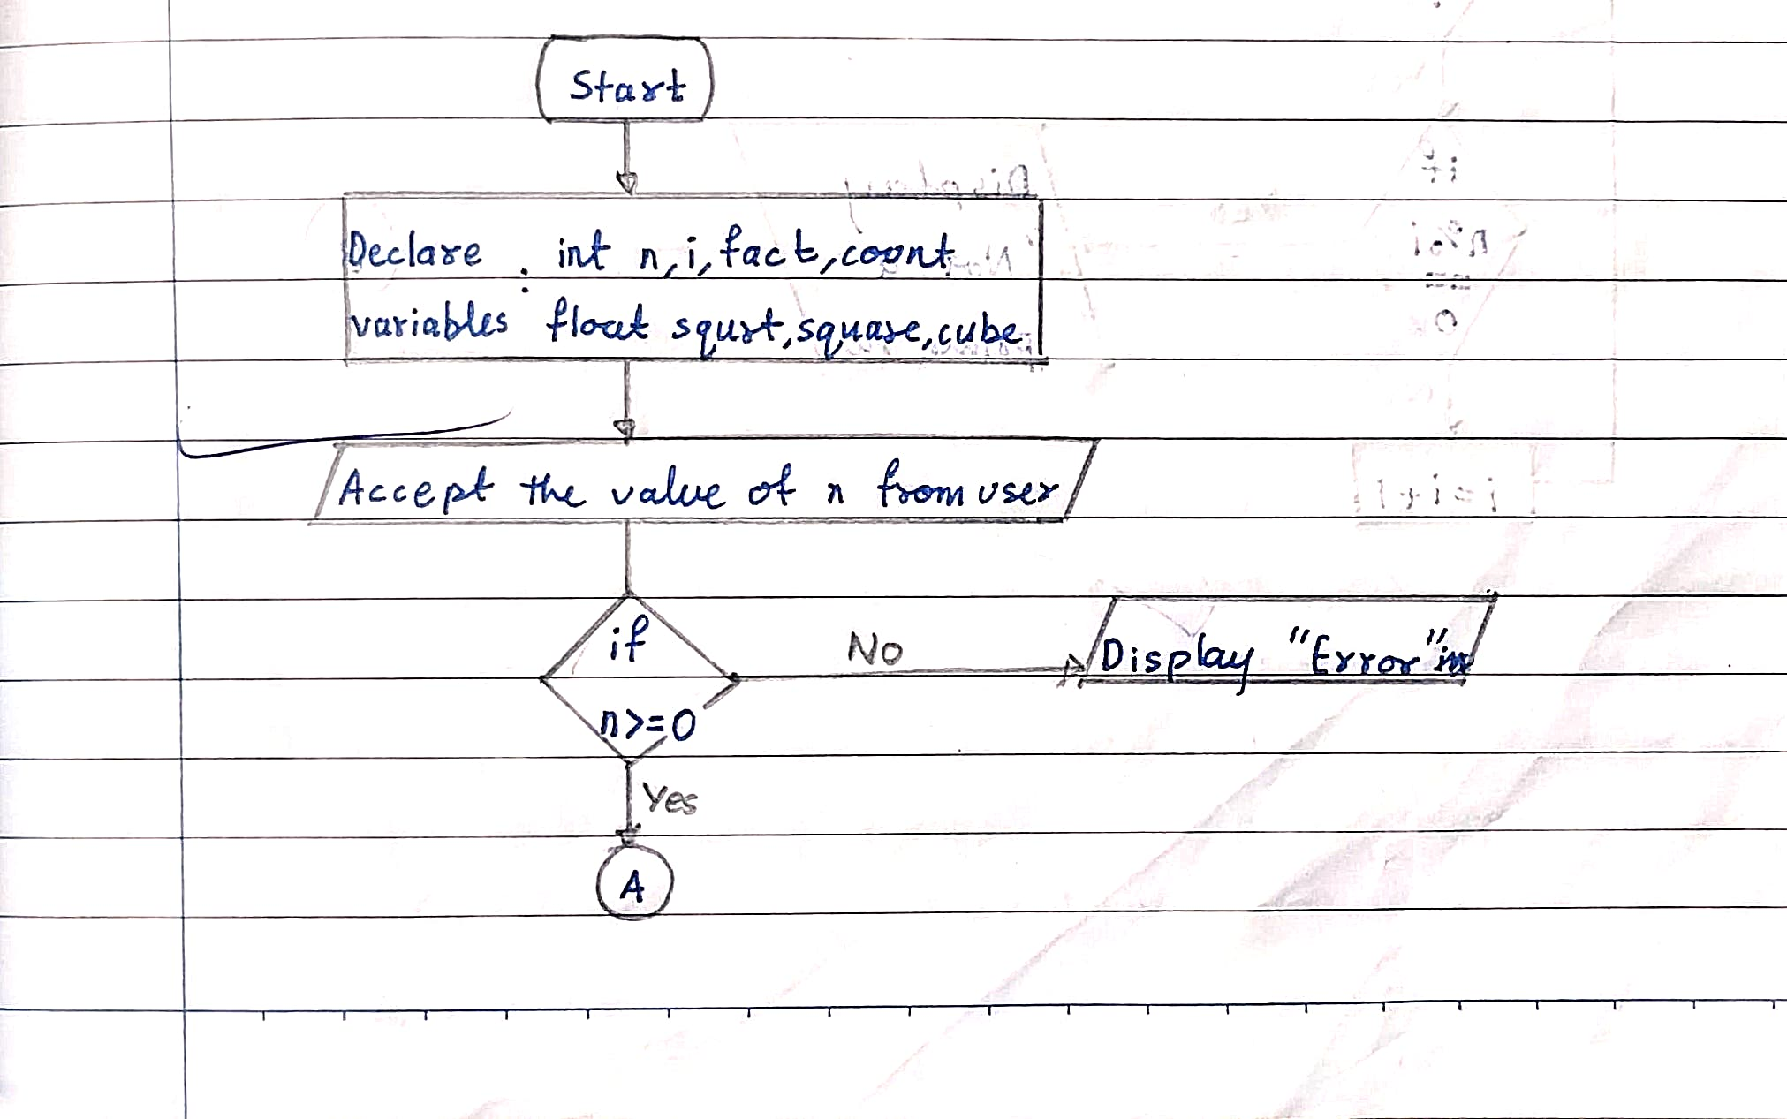
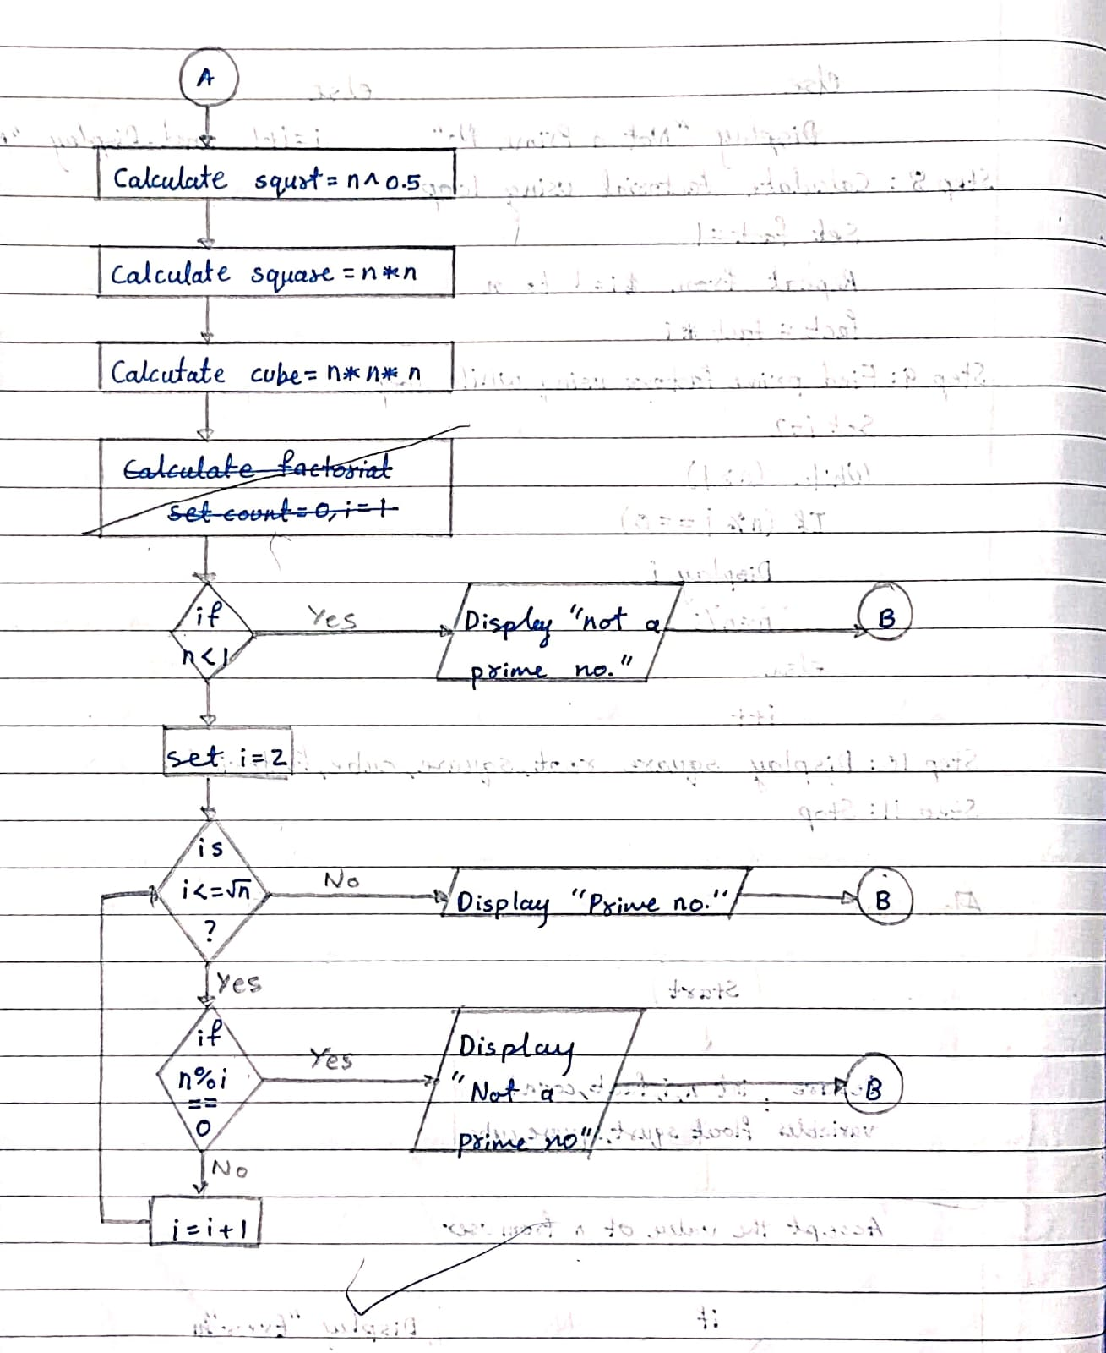
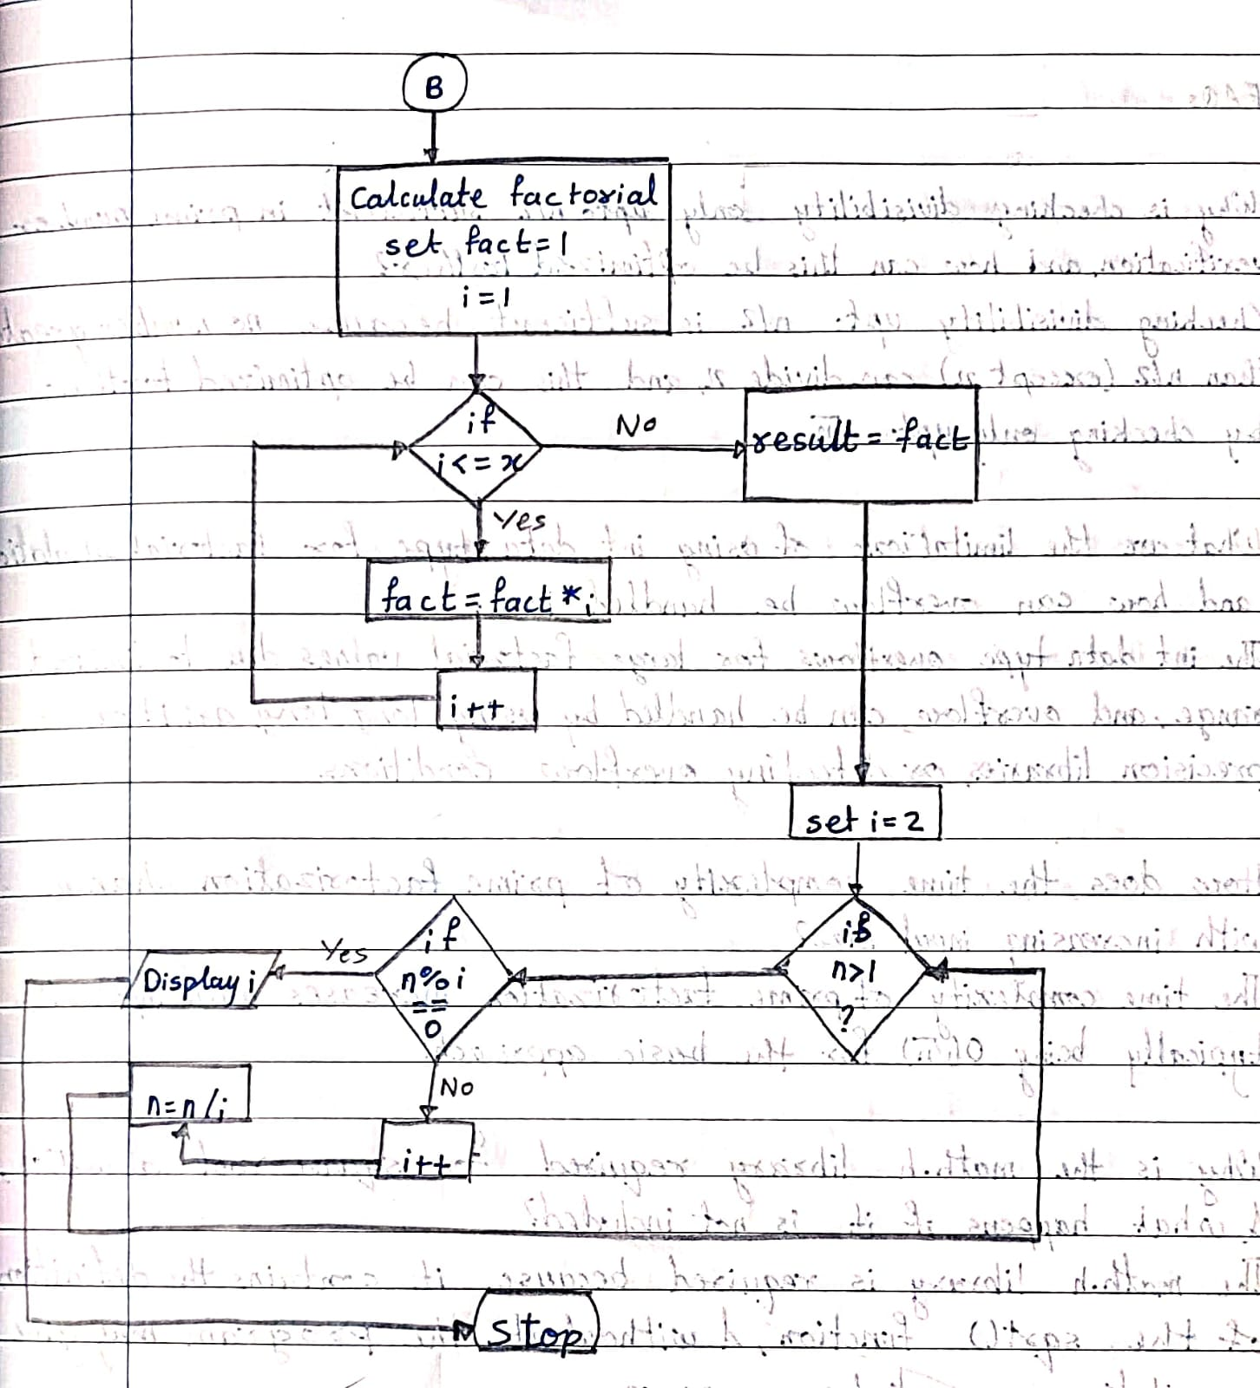

C PROGRAM:
#include <stdio.h>
#include <math.h>
int main() {
int n, i, fact = 1, result;
float squrt, square, cube;

printf("Enter a number: ");
scanf("%d", &n);
if(n >= 0)
squrt = pow(n, 0.5);
else
printf("Square root not defined for negative number\n");
square = n * n;
cube = n * n * n;
if(n <= 1) {
printf("Not a Prime Number\n");
}
else {
int prime = 1;
i = 2;

while(i <= sqrt(n)) {
if(n % i == 0) {
prime = 0;
break;
}
i++;
}

if(prime == 1)
printf("Prime Number\n");
else
printf("Not a Prime Number\n");
}
if(n < 0) {
printf("Factorial not defined for negative number\n");
}
else {
fact = 1;
for(i = 1; i <= n; i++)
fact = fact * i;
}
if(n > 1) {
int temp = n;
printf("Prime Factors: ");
i = 2;

while(temp > 1) {
if(temp % i == 0) {
printf("%d ", i);
temp = temp / i;
}
else
i++;
}
printf("\n");
}
if(n >= 0)
printf("Square Root = %.2f\n", squrt);

printf("Square = %.2f\n", square);
printf("Cube = %.2f\n", cube);

if(n >= 0)
printf("Factorial = %d\n", fact);
return 0;
}

INPUT:
The user enters an integer number and selects an operation from the menu.
Example Input: Number: 5 Choice: 3

Paste Screen Shot of Input

OUTPUT:
Example Output:
The program displays the result based on the selected operation.
Example Output: Cube = 125

Paste Screen Shot of Output
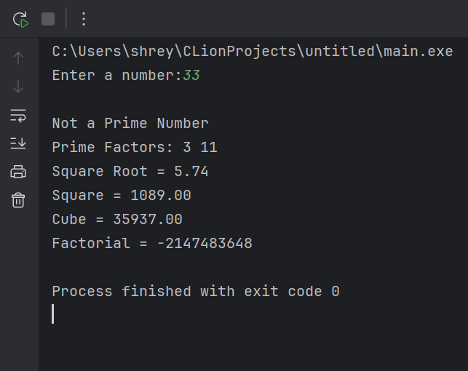

CONCLUSION:
Thus, the program to perform various mathematical operations on a number was successfully implemented using C programming. This program demonstrates the use of loops, conditional statements, switch-case, and mathematical functions.

FAQs:
- Why is checking divisibility only up to n/2 sufficient in prime number verification, and how can this be optimized further?
- What are the limitations of using int data type for factorial calculation, and how can overflow be handled in C?
- How does the time complexity of prime factorization change with increasing input size?
- Why is the math.h library required for square root calculation, and what happens if it is not included?
- How would the program behaviour change if a negative number is entered for factorial or square root operations?
- Explain the difference between checking a number for primality and generating prime factors of the same number.
- How can recursion be used to calculate factorial instead of loops, and what are its advantages and disadvantages?

